**DCS Assignment(Manan Madan)**

**Roll No : 2018UIC3087**

**Astable Multivibrator**

Astable Multivibrators are free running oscillators which oscillate between two states continually producing two square wave output waveforms.

Regenerative switching circuits such as **Astable Multivibrators** are the most commonly used type of relaxation oscillator because not only are they simple, reliable and ease of construction they also produce a constant square wave output waveform.

Unlike the Monostable Multivibrator or the Bistable Multivibrator we looked at in the previous tutorials that require an “external” trigger pulse for their operation, the **Astable Multivibrator** has automatic built in triggering which switches it continuously between its two unstable states both set and reset.

### Basic Astable Multivibrator Circuit

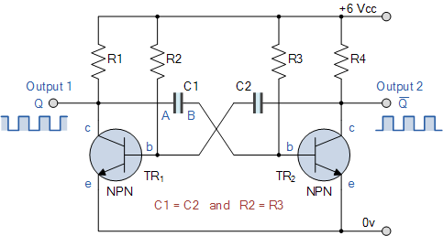

Assume a 6 volt supply and that transistor, TR1 has just switched “OFF” (cut-off) and its collector voltage is rising towards Vcc, meanwhile transistor TR2 has just turned “ON”. Plate “A” of capacitor C1 is also rising towards the +6 volts supply rail of Vcc as it is connected to the collector of TR1 which is now cut-off. Since TR1 is in cut-off, it conducts no current so there is no volt drop across load resistor R1.

The other side of capacitor, C1, plate “B”, is connected to the base terminal of transistor TR2 and at 0.6v because transistor TR2 is conducting (saturation). Therefore, capacitor C1 has a potential difference of +5.4 volts across its plates, (6.0 – 0.6v) from point A to point B.

Since TR2 is fully-on, capacitor C2 starts to charge up through resistor R2 towards Vcc. When the voltage across capacitor C2 rises to more than 0.6v, it biases transistor TR1 into conduction and into saturation.

The instant that transistor, TR1 switches “ON”, plate “A” of the capacitor which was originally at Vcc potential, immediately falls to 0.6 volts. This rapid fall of voltage on plate “A” causes an equal and instantaneous fall in voltage on plate “B” therefore plate “B” of C1 is pulled down to -5.4v (a reverse charge) and this negative voltage swing is applied the base of TR2 turning it hard “OFF”. One unstable state.

Transistor TR2 is driven into cut-off so capacitor C1 now begins to charge in the opposite direction via resistor R3 which is also connected to the +6 volts supply rail, Vcc. Thus the base of transistor TR2 is now moving upwards in a positive direction towards Vcc with a time constant equal to the C1 x R3 combination.

However, it never reaches the value of Vcc because as soon as it gets to 0.6 volts positive, transistor TR2 turns fully “ON” into saturation. This action starts the whole process over again but now with capacitor C2 taking the base of transistor TR1 to -5.4v while charging up via resistor R2 and entering the second unstable state.

Then we can see that the circuit alternates between one unstable state in which transistor TR1 is “OFF” and transistor TR2 is “ON”, and a second unstable in which TR1 is “ON” and TR2 is “OFF” at a rate determined by the RC values. This process will repeat itself over and over again as long as the supply voltage is present.

The amplitude of the output waveform is approximately the same as the supply voltage, Vcc with the time period of each switching state determined by the time constant of the RC networks connected across the base terminals of the transistors. As the transistors are switching both “ON” and “OFF”, the output at either collector will be a square wave with slightly rounded corners because of the current which charges the capacitors. This could be corrected by using more components as we will discuss later.

If the two time constants produced by C2 x R2 and C1 x R3 in the base circuits are the same, the mark-to-space ratio ( t1/t2 ) will be equal to one-to-one making the output waveform symmetrical in shape. By varying the capacitors, C1, C2 or the resistors, R2, R3 the mark-to-space ratio and therefore the frequency can be altered.

We saw in the RC Discharging tutorial that the time taken for the voltage across a capacitor to fall to half the supply voltage, 0.5Vcc is equal to 0.69 time constants of the capacitor and resistor combination. Then taking one side of the astable multivibrator, the length of time that transistor TR2 is “OFF” will be equal to 0.69T or 0.69 times the time constant of C1 x R3. Likewise, the length of time that transistor TR1 is “OFF” will be equal to 0.69T or 0.69 times the time constant of C2 x R2 and this is defined as.

### Astable Multivibrators Periodic Time

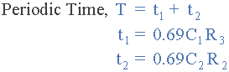

Where, R is in Ω’s and C in Farads.

By altering the time constant of just one RC network the mark-to-space ratio and frequency of the output waveform can be changed but normally by changing both RC time constants together at the same time, the output frequency will be altered keeping the mark-to-space ratios the same at one-to-one.

### Frequency of Oscillation

astable multivibrator equation

Where, R is in Ω’s, C is in Farads, T is in seconds and ƒ is in Hertz.

and this is known as the “Pulse Repetition Frequency”. So **Astable Multivibrators** can produce TWO very short square wave output waveforms from each transistor or a much longer rectangular shaped output either symmetrical or non-symmetrical depending upon the time constant of the RC network as shown below.

### Astable Multivibrator Waveforms

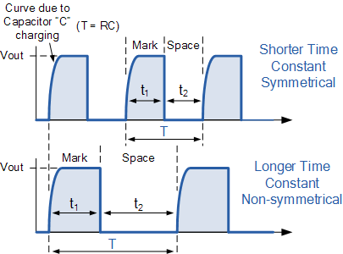

### Simple NAND Gate Monostable Circuit

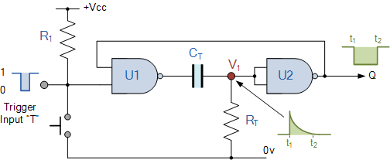

Suppose that initially the trigger input T is held HIGH at logic level “1” by the resistor R1 so that the output from the first NAND gate U1 is LOW at logic level “0”, (NAND gate principals). The timing resistor, RT is connected to a voltage level equal to logic level “0”, which will cause the capacitor, CT to be discharged. The output of U1 is LOW, timing capacitor CT is completely discharged therefore junction V1 is also equal to “0” resulting in the output from the second NAND gate U2, which is connected as an inverting NOT gate will therefore be HIGH.

The output from the second NAND gate, ( U2 ) is fed back to one input of U1 to provide the necessary positive feedback. Since the junction V1 and the output of U1 are both at logic “0” no current flows in the capacitor CT. This results in the circuit being Stable and it will remain in this state until the trigger input T changes.

If a negative pulse is now applied either externally or by the action of the push-button to the trigger input of the NAND gate U1, the output of U1 will go HIGH to logic “1” (NAND gate principles).

Since the voltage across the capacitor cannot change instantaneously (capacitor charging principals) this will cause the junction at V1 and also the input to U2 to also go HIGH, which in turn will make the output of the NAND gate U2 change LOW to logic “0” The circuit will now remain in this second state even if the trigger input pulse T is removed. This is known as the Meta-stable state.

The voltage across the capacitor will now increase as the capacitor CT starts to charge up from the output of U1 at a time constant determined by the resistor/capacitor combination. This charging process continues until the charging current is unable to hold the input of U2 and therefore junction V1 HIGH.

When this happens, the output of U2 switches HIGH again, logic “1”, which in turn causes the output of U1 to go LOW and the capacitor discharges into the output of U1 under the influence of resistor RT. The circuit has now switched back to its original stable state.

Thus for each negative going trigger pulse, the monostable multivibrator circuit produces a LOW going output pulse. The length of the output time period is determined by the capacitor/resistor combination ([RC Network](https://www.electronics-tutorials.ws/rc/rc_1.html)) and is given as the Time Constant T = 0.69RC of the circuit in seconds. Since the input impedance of the NAND gates is very high, large timing periods can be achieved.

As well as the NAND gate monostable type circuit above, it is also possible to build simple monostable timing circuits that start their timing sequence from the rising-edge of the trigger pulse using NOT gates, NAND gates and NOR gates connected as inverters as shown below.

# Bistable Multivibrator

Bistable Multivibrators operate in a similar fashion to flip-flops producing one of two stable outputs which are the complement of each other.

The **Bistable Multivibrator** is another type of two state device similar to the Monostable Multivibrator we looked at in the previous tutorial but the difference this time is that BOTH states are stable.

Bistable Multivibrators have TWO stable states (hence the name: “Bi” meaning two) and maintain a given output state indefinitely unless an external trigger is applied forcing it to change state.

The bistable multivibrator can be switched over from one stable state to the other by the application of an external trigger pulse thus, it requires two external trigger pulses before it returns back to its original state. As bistable multivibrators have two stable states they are more commonly known as Latches and Flip-flops for use in sequential type circuits.

The discrete **Bistable Multivibrator** is a two state non-regenerative device constructed from two cross-coupled transistors operating as “ON-OFF” transistor switches. In each of the two states, one of the transistors is cut-off while the other transistor is in saturation, this means that the bistable circuit is capable of remaining indefinitely in either stable state.

To change the bistable over from one state to the other, the bistable circuit requires a suitable trigger pulse and to go through a full cycle, two triggering pulses, one for each stage are required. Its more common name or term of “flip-flop” relates to the actual operation of the device, as it “flips” into one logic state, remains there and then changes or “flops” back into its first original state. Consider the circuit below.

### Bistable Multivibrator Circuit

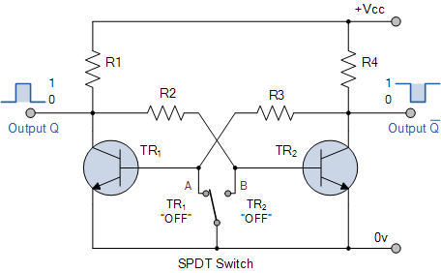

The **Bistable Multivibrator** circuit above is stable in both states, either with one transistor “OFF” and the other “ON” or with the first transistor “ON” and the second “OFF”. Lets suppose that the switch is in the left position, position “A”. The base of transistor TR1 will be grounded and in its cut-off region producing an output at Q. That would mean that transistor TR2 is “ON” as its base is connected to Vcc through the series combination of resistors R1 and R2. As transistor TR2 is “ON” there will be zero output at Q, the opposite or inverse of Q.

If the switch is now move to the right, position “B”, transistor TR2 will switch “OFF” and transistor TR1 will switch “ON” through the combination of resistors R3 and R4 resulting in an output at Q and zero output at Q the reverse of above. Then we can say that one stable state exists when transistor TR1 is “ON” and TR2 is “OFF”, switch position “A”, and another stable state exists when transistor TR1 is “OFF” and TR2 is “ON”, switch position “B”.

Then unlike the monostable multivibrator whose output is dependent upon the RC time constant of the feedback components used, the bistable multivibrators output is dependent upon the application of two individual trigger pulses, switch position “A” or position “B”.

So **Bistable Multivibrators** can produce a very short output pulse or a much longer rectangular shaped output whose leading edge rises in time with the externally applied trigger pulse and whose trailing edge is dependent upon a second trigger pulse as shown below.

### Bistable Multivibrator Waveform

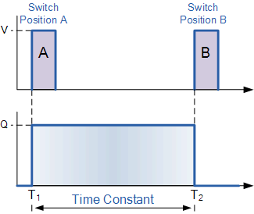

Manually switching between the two stable states may produce a bistable multivibrator circuit but is not very practical. One way of toggling between the two states using just one single trigger pulse is shown below.

## TTL/CMOS Bistable Multivibrators

As well as producing a bistable multivibrator from individual discrete components such as transistors, we can also construct bistable circuits using commonly available integrated circuits. The following circuit shows how a basic bistable multivibrator circuit can be constructed using just two 2-input Logic “NAND” Gates.

### NAND Gate Bistable Multivibrator

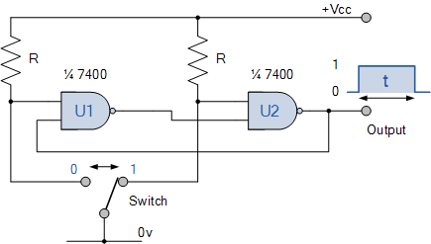

The circuit above shows us how we can use two NAND gates connected together to form a basic bistable multivibrator. This type of bistable circuit is also known as a “Bistable Flip-flop”. The manually controlled bistable multivibrator is activated by the single-pole double-throw switch (SPDT) to produce a logic “1” or a logic “0” signal at the output.

You may have noticed that this circuit looks a little familiar, and you would be right!. This type of bistable switching circuit is more commonly called a SR NAND Gate Flip-flop being almost identical to the one we looked at back in the sequential logic tutorials. In that particular tutorial we saw that this type of NAND gate bistable makes an excellent “switch debounce” circuit allowing only one switching action to control its output.

In the next tutorial about *Multivibrators*, we will look at one that has NO stable states because it is continually switching over from one stable state to the other. This type of multivibrator circuit is called an Astable Multivibrator also known by their more common name of “fee-running oscillator”.